First announcement and Call for Papers
International Workshop on Inductive Modelling
July 8-14, 2012, Zhukyn, Kyiv Oblast, Ukraine
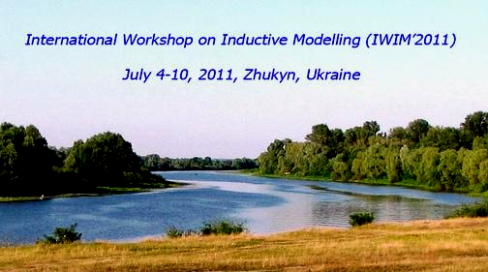
The workshop focuses on theory, algorithms, applications, and new developments of data mining and knowledge extraction technologies which originate from GMDH as a typical inductive modelling method. The workshop motivation is to analyze the state-of-the-art of modelling methods that inductively generate models from data, to discuss concepts of an automated knowledge discovery workflow, to share new ideas on model validation and visualization, to present novel applications in different areas.
Topics of interest include but are not limited to:
SECTION 1. THEORETICAL FUNDAMENTALS OF INDUCTIVE MODELING
- Optimal complexity of inductive models, regularization, selection criteria;
- Enhanced and optimized GMDH algorithms;
- Inductive algorithms for classification, clusterization, recognition;
- Inductive Modelling as an apparatus of Computational Intelligence;
SECTION 2. NEW APPROACHES IN INDUCTIVE MODELLING
- Hybrid GMDH-type algorithms and neural networks;
- Optimization and evolution of inductive neural networks;
- Fuzzy and interval approaches in inductive modelling
- Inductive models ensembles, neural networks ensembles;
- High-performance computing, including parallel and distributed computing;
- Visual data mining, model visualization;
SECTION 3. REAL-WORLD APPLICATIONS OF INDUCTIVE MODELLING
- Data & knowledge mining, relationships detection using inductive modelling;
- Knowledge discovery workflow automation, automated data preprocessing;
- Applied software tools for construction of inductive models;
- Time series analysis and prediction by means of inductive models;
- Real-world applications, including solutions in ecology, economy, sociology, medicine, technology, bioinformatics.
IMPORTANT DATES
April 30, 2012 – deadline for extended abstracts submission.
May 10, 2012 – notification of acceptance.
May 31, 2012 – camera-ready due.
SUBMISSION
Original papers not being submitted to journals or other conferences will be considered. We encourage authors to present position papers on theoretical and practical studies, emerging issues, and novel ideas under development.
Papers must be submitted in two steps: 1) extended abstracts (up to an A4 half-page), and 2) camera-ready manuscript submission. Manuscripts may be limited to 10 fully filled pages. The papers format must follow the proceedings guidelines (see http:// icim2010.felk.cvut.cz/submission.php). Sending ready manuscripts instead of extended abstracts is strongly encouraged.
Accepted papers will be published in the Proceedings of the 5th IWIM’2012 under ISBN index. Authors of selected papers will be invited to extend their contribution to the annual issue of collected papers “Inductive Modelling of complex systems”.
CONFERENCE ORGANIZERS
- International Research and Training Centre for Information Technologies and Systems of the National Academy of Sciences and Ministry of Education and Science of Ukraine (IRTC ITS)
- Czech Technical University in Prague, Czech Republic (CTU in Prague)
CHAIRS

Volodymyr Stepashko (Chairman)
Professor, Head of Department for
Information Technologies and Systems, IRTC ITS
e-mail: stepashko@irtc.org.ua
Pavel Kordík (Secretary)
Assistant Professor, Vice Dean
Faculty of Information Technology, CTU in Prague
e-mail: kordikp@fit.cvut.cz

INTERNATIONAL PROGRAM COMMITTEE
Tetiana Aksenova Grenoble University, France
Hamparsum Bozdogan The University of Tennessee, USA
He Changzheng Sichuan University, Chengdu, China
John Elder Elder Research, USA
Tadashi Kondo The University of Tokushima, Japan
Pavel Kordík Czech Technical University, Czech Republic
Frank Lemke KnowledgeMiner Software, Berlin, Germany
Panos Liatsis City University London, UK
Nader Nariman-zadeh The University of Guilan, Iran
Godfrey Onwubolu University of the South Pacific, Suva, Fiji
Witold Pedrycz University of Alberta, Canada
Volodymyr Stepashko IRTC ITS, Kyiv, Ukraine
Miroslav Šnorek Czech Technical University, Czech Republic
Nikolai Zagoruiko Novosibirsk State University, Russian Federation

LOCAL ORGANIZING COMMITTEE

Ievgenia Savchenko (Secretary)
Ludmyla Somina
Serhiy Yefimenko
Halyna Pidnebesna
Andriy Pavlov

International Research and Training Centre
for Information Technologies and Systems
of the NAS and MES of Ukraine

CONFERENCE VENUE
The IRTC physico-mathematical school is located in a camp near small village Zhukyn on the right branch bank of the river Desna in an extremely scenic part of Kyiv Oblast (thick pine forest, green meadows, sandy beach).
Participants are housed in bungalows (small wooden houses with a four-bed room). This is “zero-stared” fully original “soviet style service” without customary conveniences like w.c., shower-bath, TV. Public lavatories, again of typical “soviet style”, are placed over the margins of the school territory.
However pay your attention to the fact that this unique kind of accommodation is completely for free.
Participants cook meals on their own: every house has a kitchen equipped with main vital devices (cooking battery, gas-stove, and refrigerator). At the territory there is also a food store selling bread, cereals, canned and beverage foods etc.
Those preferring comfortable not country conditions could also stay at any hotel in Kyiv and come every day to the workshop place: buses from Kyiv may bring you there and back during 1 hour (they go near the camp approx. every half-hour).
Typically a working day of the workshop is planned to be as follows:
- joint session in the morning;
- free time in the afternoon: fine sunny weather is guaranteed so you will have favourable conditions for swimming, tanning, jogging, biking, traveling, fishing, mushrooming, and many other “ings”;
- heart-to-heart talks and songs to a guitar by a bonfire in the evening.
There won’t be any time to feel bored. Having equipment for sports and fishing is strongly encouraged.

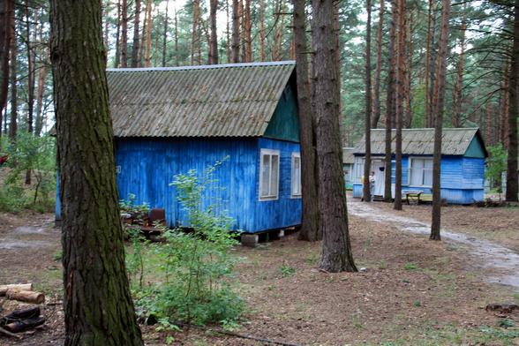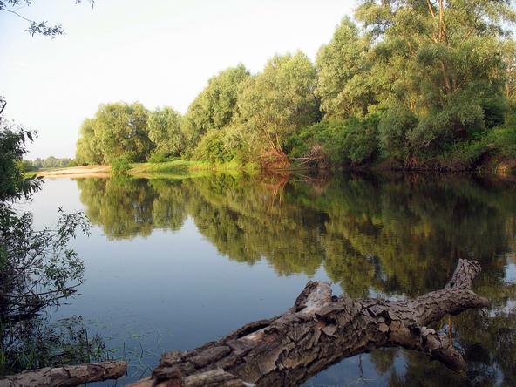

More pictures from the Workshop venue see on www.mgua.irtc.org.ua

GENERAL INQUIRIES
For updated information, please contact the workshop local committee secretary savchenko@irtc.org.ua.

