INTERMODAL REGISTRATION ALGORITHM FOR SEGMENTATION OF MOUSE BRAIN IMAGES¹
P. Voronin², D. Vetrov³

² Russian Research Center "Kurchatov Institute", e-mail: pavel.voronin@gmail.com
³ Moscow State University, e-mail: vetrovd@yandex.ru
We propose a novel intermodal registration algorithm, based on maximization of mutual information. The method combines several existing approaches, while adding some new techniques, ensuring a more robust registration process. The algorithm is designed as a tool for segmentation of the images of mouse brain sections.

Introduction
In recent years, studying gene expression in brain cells became one of the most important topics in the research of the mechanisms underlying cognitive processes. Standard lab animals, mainly mice and rats, have been used to study expression patterns in the brain structures. Several industrial-scale projects, including Allen Brain Atlas [1] and GeneAtlas [2], popularized in situ hybridization (ISH) as a means of acquiring gene localization data. This technique results in images of brain sections, in which neurons expressing the gene of interest can be distinguished from all others (Fig. 1). Structural analysis of such data naturally demands segmentation of the images into distinct anatomical regions.
Manual segmentation is a very time-consuming (and thus, expensive), tedious, subjective and error-prone process. Consequently, various automatic and semi-automatic brain segmentation algorithms have been proposed in the literature: active shape methods are based on fitting a set of segment boundaries by matching the local appearance to a pre-learned model [3]; MRF-based methods use data-driven probabilistic models to solve pixel classification problem [4]; registration-based methods seek to transform the image so that it matches a reference (atlas) image with a known segmentation [5]. The last approach is the most general one, as it doesn’t need prior information on the structure of the image being segmented.
Image registration is a well-studied problem with a plethora of application-specific and general methods available [6]. Nevertheless, peculiarities of the problem at hand make it very difficult to use an out-of-the-box solution. Since images of ISH-stained brain sections can be very noisy and low-contrast, we can’t use methods based on matching of salient features (points or edges). Another major problem is the difference in modalities between reference and experimental images (usually, atlas images are generated from Nissl-stained sections [1]); this means that direct comparison of the images’ pixels is meaningless and we can only use intermodal algorithms. Finally, brain’s elasticity and significant inter-subject variation mean we need a method capable of compensating for both global rigid motions and local non-rigid transformations.
In its entirety, the problem of finding a general robust algorithm for non-rigid intermodal registration of featureless images is unsolved and remains a topic of ongoing research. In this paper, we combine several existing and new techniques to produce a novel method for intermodal registration of brain images.
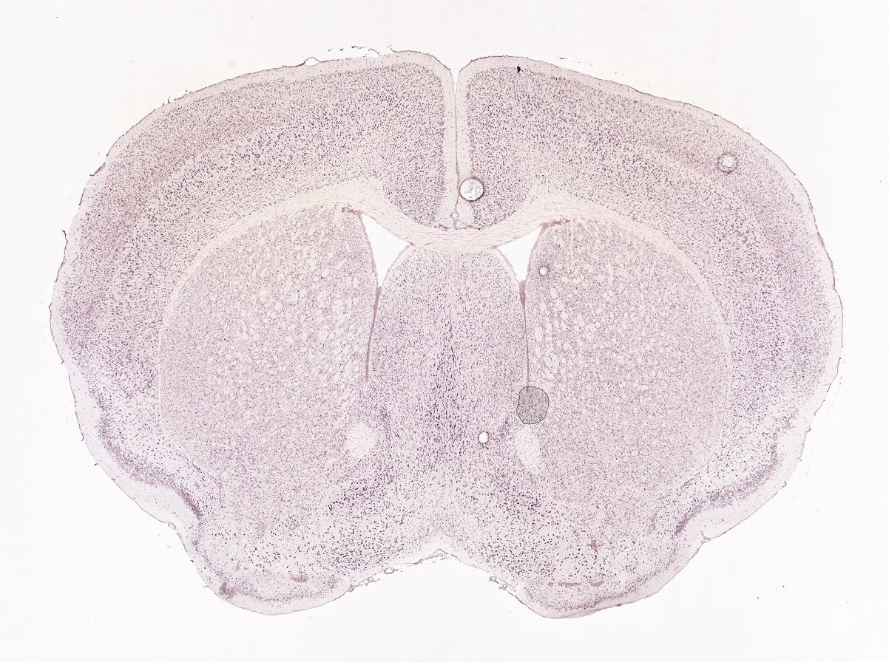 | 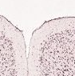
Fig. 1. Left, ISH-stained section; right, detail, shows cell-level resolution.
Intermodal registration
The problem of image registration can be formulated as follows:

$T^{}=\text{arg}\underset{T∈Ω}{\text{max}}\text{Sim}\left(A,T\left(B\right)\right)$, | (1)
where A and B are the images (comprising of pixels with discrete intensities, 0 to n); Ω is the set of permitted transformations (transformation space); Sim is the similarity measure.
Among the many measures proposed for the image registration, we chose mutual information, which is specifically designed for modalities only exhibiting statistical correspondences [7]. Let us model pixel intensities of A, B by random variables with distributions p_{A}, p_{B} and joint distribution p_{AB}. Mutual information of these variables is:

$$\text{MI}(A,B)=\sum_{i,j}^{n}{p_{\text{AB}}(i,j)\text{log}\frac{p_{\text{AB}}(i,j)}{p_{A}(i)p_{B}(j)}}\text{.}$$ | (2)
The name of the measure is justified by its relation to Shannon’s entropy H:

$$H(A)=−\sum_{i=0}^{n}{p_{A}(i)\text{log}p_{A}(i)}$$  $$H(A,B)=−\sum_{i,j=0}^{n}{p_{\text{AB}}(i,j)\text{log}p_{\text{AB}}(i,j)}$$  $$\text{MI}(A,B)=H(A)+H(B)−H(A,B)$$ | (3)
I. e., it is a measure of the amount of information that the variables contain about each other. Put another way, it is a quantitative characteristic of the mutual dependence of the two variables.
Depending on the size of images and time constraints, distributions p_{A}, p_{B} and p_{AB} can be estimated via histogramming, Parzen filtering or one of their variations [6, 7].
Complexity of the optimization problem (1) strongly depends on the dimensionality of the transformation space. Thus, for robustness, registration is usually decomposed into linear (simple matrix multiplication, low dimensional space) and non-linear (potentially infinite-dimensional space). In our case we start with a six-dimensional affine transformations space:
$T^{}=\text{arg}\underset{T∈\text{Aff}}{\text{max}}\text{MI}\left(A,T\left(B\right)\right)$. | (1*)
Even if have a good initial guess and only need a crude estimate of the optimal transformation, brute force optimization is impractical (MI is an expensive calculation). On the other hand, we can’t use any of the fast gradient-based optimization algorithms, since we do not have access to the measure’s derivatives. Of the many derivative-free optimization methods available, we’ve chosen the recent NEWUOA algorithm, known to outperform its predecessors in terms of accuracy and speed [8]. In our experience, it is also more robust than the ones traditionally used for image registration [6].
Non-linear registration
It is easy to see that the scheme described above has to be changed for the case of higher-order transformations. Even though NEWUOA can solve optimization problems in spaces with as many as 200 dimensions, for expensive functions it becomes impractical much earlier. For reference, one popular way to define non-linear transformation, B-splines [9], needs 800 variables for a humble 20x20 grid-based field.

One possible solution is to gradually construct the global transformation as a weighted composition of locally-optimal low-dimensional transformations [10]. Let us define the transformation via a vector field:
$\begin{aligned}\vec{T}\left(i,j\right)=\left(T_{x}\left(i,j\right),T_{y}\left(i,j\right)\right) \\ \left(T\left(B\right)\right)\left(i,j\right)=B\left(T_{x}\left(i,j\right),T_{y}\left(i,j\right)\right)\end{aligned}$. | (4)
Then the iteration scheme can be put like this:

$\begin{aligned}T_{0}=E, \\ T_{k}^{\text{loc}}=\text{arg}\underset{T∈\text{Aff}}{\text{max}}\text{MI}(A,T(T_{k−1}(B_{k}^{\text{loc}}))), \\ T_{k}=Ψ_{k}^{\text{loc}}⋅T_{k}^{\text{loc}}T_{k−1}+(1−Ψ_{k}^{\text{loc}})⋅T_{k−1}, \\ Ψ_{k}^{\text{loc}}(\vec{x})=\frac{1}{1+{\left(\left\|\vec{x}−{\vec{c}}_{k}^{\text{loc}}\right\|r_{k}^{\text{loc}}\right)}^{4}},\end{aligned}$ (5)
where $T_{k}^{\text{loc}}$ is the locally-optimal affine transformation; $Ψ_{k}^{\text{loc}}$is a 2nd-order Butterworth weight function (note that blending only occurs for transformations and not for images); ${\left\{B_{k}^{\text{loc}}\right\}}_{k=1}^{K}$ is a sequence of subimages (patches) with centers $c_{k}^{\text{loc}}$ and radii $r_{k}^{\text{loc}}$.

Working with patches instead of the whole image results in a fast algorithm, but it also brings the problem of lower robustness (caused by density estimation from fewer samples and potential inadequacy of the affine model for a particular local transformation). Careful choice of the patches can alleviate the negative effect. Usually, patches are chosen to densely cover the image in a hierarchical manner, so that coarse deformations are compensated first, while leaving minutia for later. If in addition patches are partially overlapping, the scheme becomes somewhat self-correcting: overfitting any patch may still be compensated for when processing its neighbors.
A natural choice for a sequence meeting the requirements specified above is the standard hierarchical pyramid subdivision: first we subdivide the image into 4 equal overlapping part; process them; subdivide the image into 16 parts; process them; etc.

Nevertheless, the problem remains: the algorithm lacks explicit transformation field quality control. Therefore, we added an additional control step to (5):

$$\begin{aligned}T_{k}^{\text{loc}}=\text{arg}\underset{T∈Ω}{\text{max}}\text{MI}(A,T(T_{k−1}(B_{k}^{\text{loc}}))), \\ T_{k}^{\text{glob}}=Ψ_{k}^{\text{loc}}⋅T_{k}^{\text{loc}}T_{k−1}+(1−Ψ_{k}^{\text{loc}})⋅T_{k−1}, \\ F(A,B,T_{k}^{\text{glob}})>F(A,B,T_{k−1})⇒T_{k}=T_{k}^{\text{glob}}, \\ F(A,B,T_{k}^{\text{glob}})≤F(A,B,T_{k−1})⇒T_{k}=T_{k−1}\text{.}\end{aligned}$$ | (5*)
Control step ensures that no iteration leads to decreasing of the quality measure F(A, B, T) of the global transformation. To measure the quality of a transformation we propose to use a regularized version of mutual information:

$$F(A,B,T)=\text{MI}(A,T(B))−λ⋅E(T),$$  $$E(T)=\iint{\left({\left(\frac{∂^{2}T}{∂x^{2}}\right)}^{2}+2{\left(\frac{∂^{2}T}{∂x∂y}\right)}^{2}+{\left(\frac{∂^{2}T}{∂y^{2}}\right)}^{2}\right)\text{dxdy}}\text{.}$$ | (6)
This kind of measures is commonly used in elastic and fluid registration methods, wherein it is optimized directly [6]. Note that this cannot be done in our approach, as for any affine transformation T_{aff} , E(T_{aff}) ≡ 0.
Robust registration
As noted above, algorithm (5 / 5*) is very sensitive to the choice of patches. The pyramid sequence has some desirable qualities (described above); nevertheless, its data-independent structure can still lead to certain problems. Firstly, a patch chosen this way can be featureless (blank, homogeneous or containing nothing but noise). Registering such patches doesn’t just take unnecessary time, but also can and does give efficiently random result. Secondly, strong feature may be cut across by the patches’ boundaries, thus being registered in parts and not as a whole. Both problems can lead to the deterioration of the registration quality.

The first problem has been addressed in a recent paper [11]. Authors used spatial autocorrelation coefficient known as Moran’s I [12] to evaluate the amount of structure in the patches from the pyramid sequence, and Student’s t-test to discard those that do not contain salient features.

We propose to go one step further. By calculating Moran’s I map for the whole image (running window-style), we can distribute patches from every hierarchical level over the features most salient at the corresponding scale (Fig. 2).
Conclusion
In this paper we proposed a novel algorithm for intermodal registration of mouse brain images.
The algorithm has been designed as a tool for automated segmentation of the images of experimental in situ hybridization stained sections.
Fig. 3 and Fig.4 reproduce an example of the proposed algorithm’s work.

References
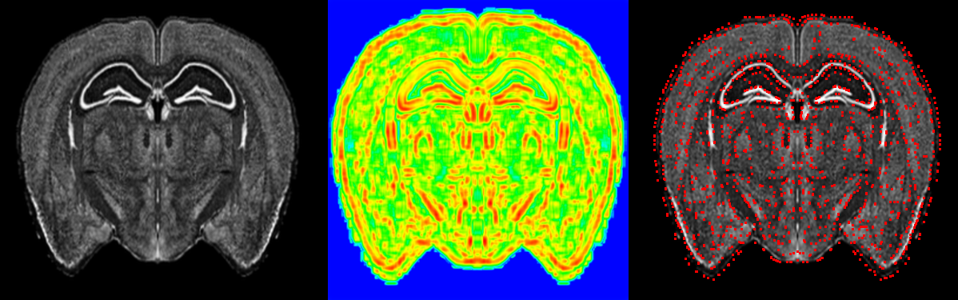
Fig. 2. Distributing patches: left, experimental section; center, Moran’s I map; right, centers of the patches.

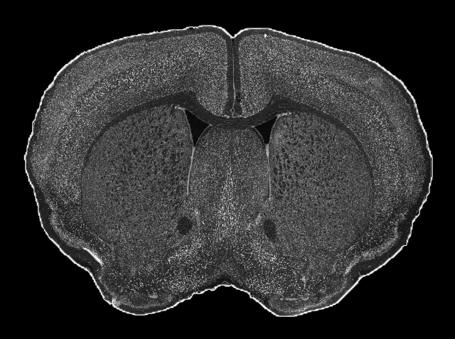 | 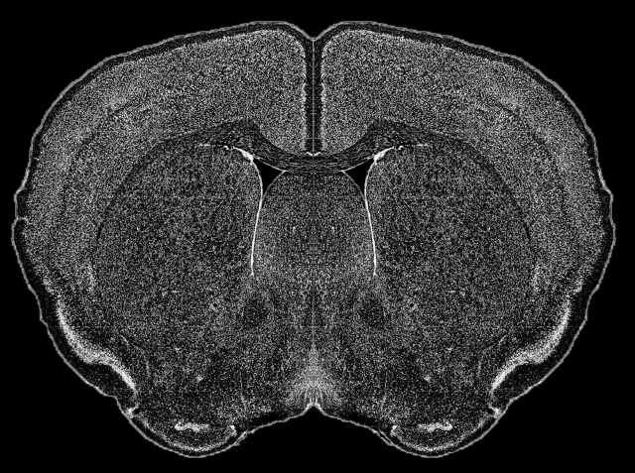 | 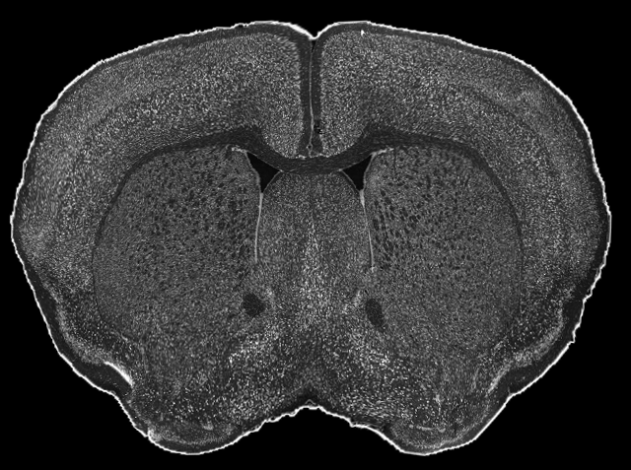
Fig. 3. Sample result: left, experimental ISH-stained section; center, reference Nissl-stained section; right, experimental section registered by the proposed algorithm.

- E.S. Lein et al. Genome-wide atlas of gene expression in the adult mouse brain. // Nature. - 2007. - Vol. 445, No.7124. - P. 168-176.
- J. Carsona, T. Ju, M. Bello, C. Thaller, J. Warren, I.A. Kakadiaris, W. Chiu, G. Eichele. Automated pipeline for atlas-based annotation of gene expression patterns: Application to postnatal day 7 mouse brain // Methods. - 2010. - Vol. 50, No.2. - P. 85-95.
- T. Ju, J. Carson, L. Liu, J. Warren, M. Bello, I. Kakadiaris. Subdivision meshes for organizing spatial biomedical data // Methods. - 2010. - Vol. 50, No.2. - P. 70-76.
- M.H. Bae, R. Pan, T. Wu, A. Badea. Automated Segmentation of Mouse Brain Images Using Extended MRF // Neuroimage. - 2009. - Vol. 46, No.3. - P. 717-725.
- L. Ng et al. Neuroinformatics for genome-wide 3-D gene expression mapping in the mouse brain // IEEE Transactions on Computational Biology and Bioinfomatics. - 2007. - Vol. 4, No.3. - P. 382-393.
- B. Zitova, J. Flusser. Image registration methods: a survey // Image and Vision Computing. - 2003. - Vol. 21, No.11. - P. 977-1000.
- J.P.W. Pluim, J.B.A. Maintz, M.A. Viergever. Mutual-information-based registration of medical images: a survey // IEEE Transactions on Medical Imaging. - 2003. - Vol. 22 - P. 977-1000.
- M.J.D. Powell. A view of algorithms for optimization without derivatives // Cambridge NA Reports, Optimization Online Digest. - 2007.
- H. Prautzsc, W. Boehm, M. Paluszny. Bezier and B-spline techniques // Springer. - 2002.
- E. Ardizzone, O. Gambino, M. La Cascia, L. Lo Presti, R. Pirrone. Multi-modal non-rigid registration of medical images based on mutual information maximization. // Proceedings of ICIAP. - 2007. - P. 743-750.
- A. Andronache, M. von Siebenthal, G. Szekely, Ph. Cattin. Non-rigid registration of multi-modal images using both mutual information and cross-correlation // Medican Image Analysis. - 2008. - Vol. 12, No.1. - P. 3-15.
- A. Cliff, J. Ord. Spatial Autocorrelation // Pion Limited. - 1973.

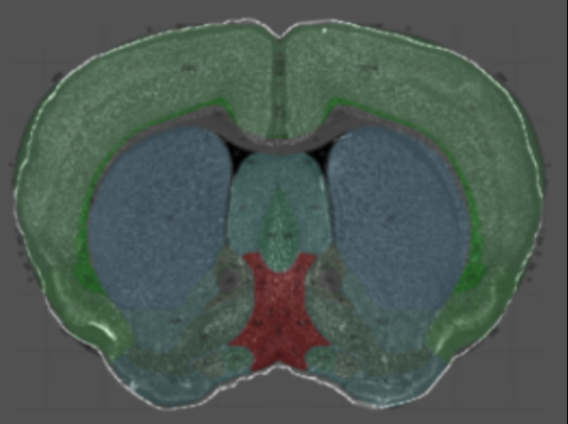
Fig. 4. Registered section, with segmentation overlaid.

